Ex. No. 5

**INSTALLATION AND CONFIGURATION OF CLOUDSIM IN ECLIPSE IDE**

# AIM:

To install and configure the CloudSim in Eclipse IDE and run a java program in it.

# PROCEDURE:

1. **Java Installation**
   1. Check java in your system.
   2. If java not installed then download Java.
   3. Install java setup.
   4. Set path variable for java.

# Download CloudSim and additional jar file

* 1. Download CloudSim 3.0.3
  2. Download Commons math 3 jar file.

# Eclipse IDE Installation

* 1. If java 64 bit Installed then download 64-bit Eclipse otherwise java 32 bit then download 32 eclipse.
  2. Install Eclipse IDE.

# Run CloudSim in Eclipse

* 1. Put up commons-math-3-3.6.1.jar file into jar folder of Cloudsim3.0.3
  2. Build a new java project with Cloudsim3.0.3 folder.

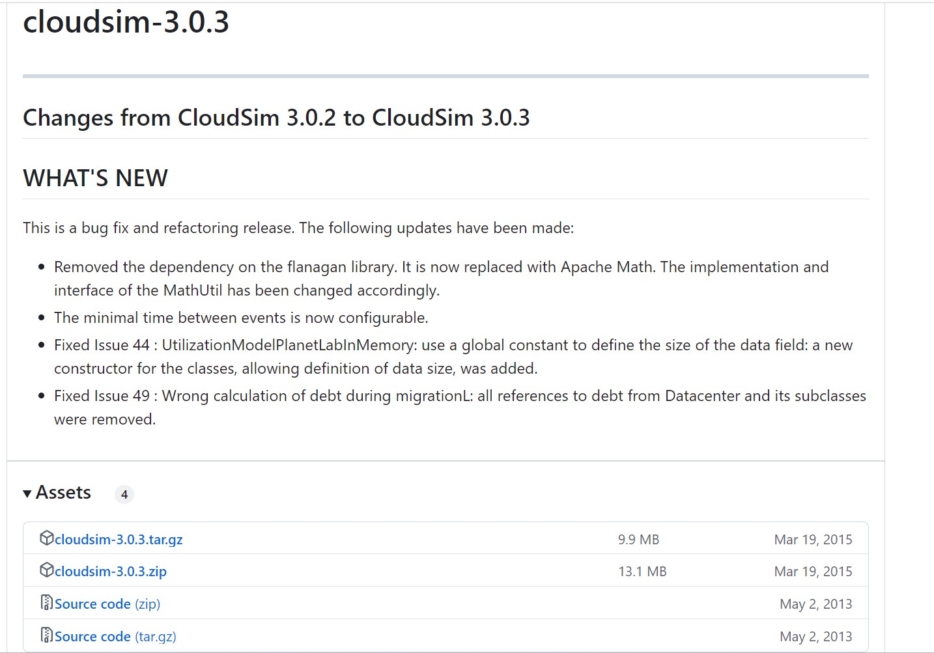

Download the .zip file

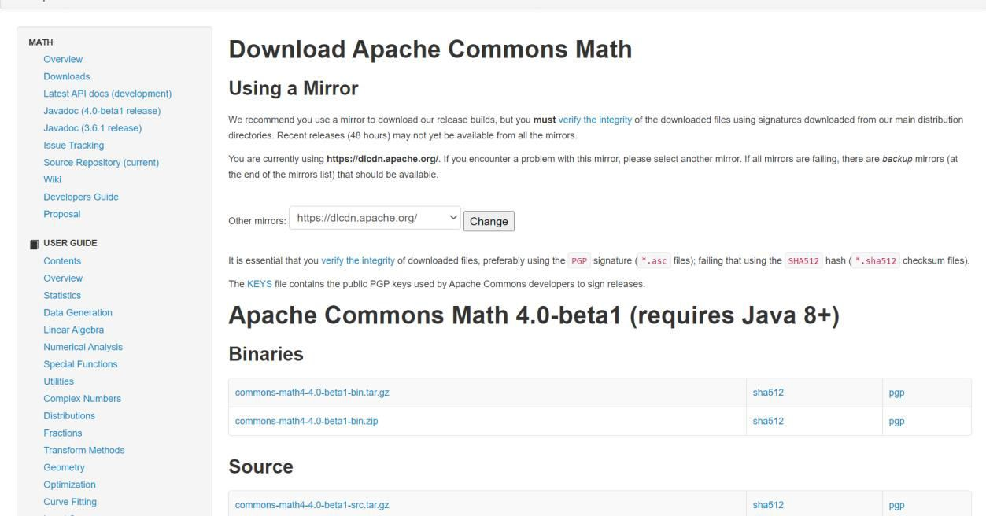

Download the .zip file

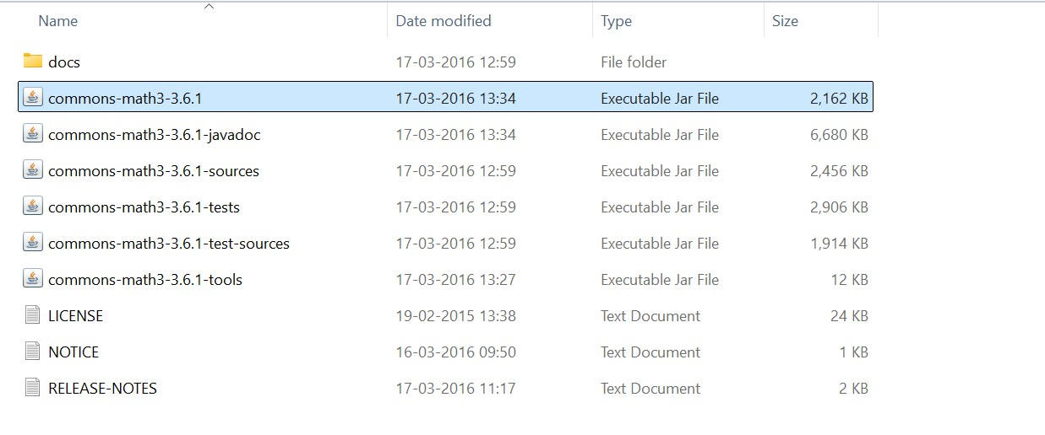

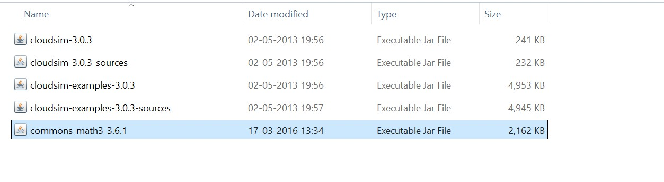

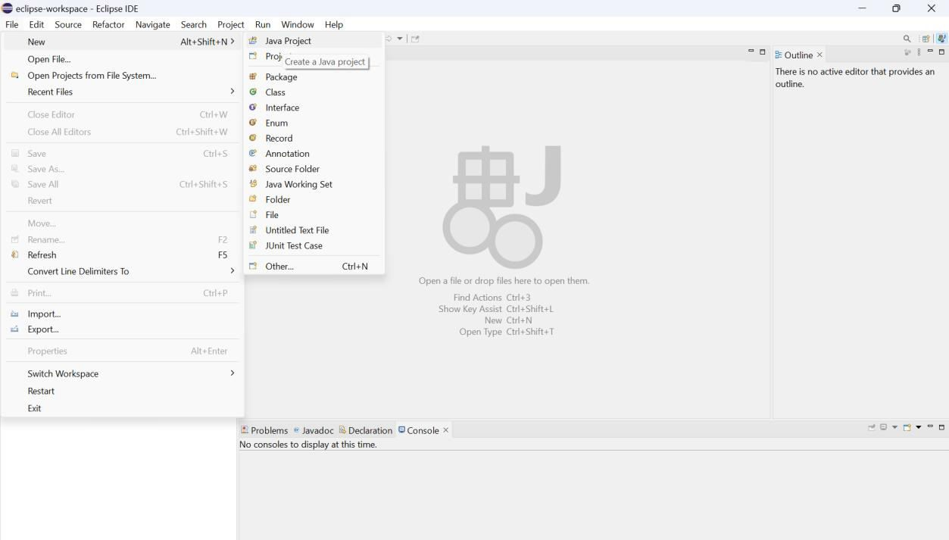

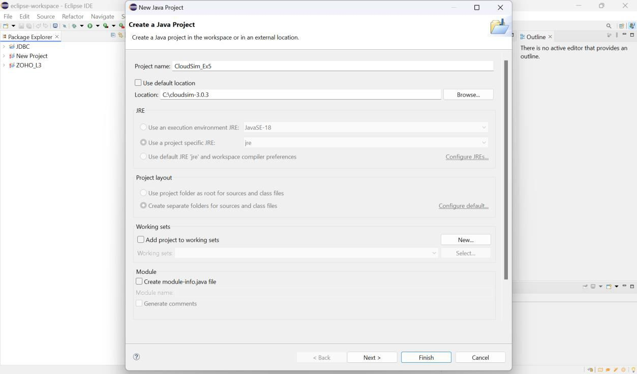

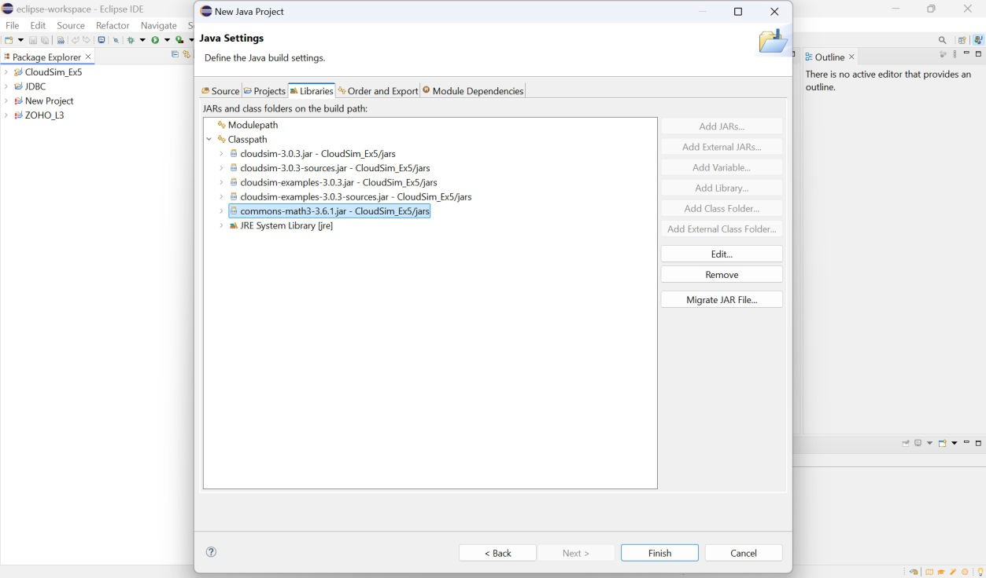

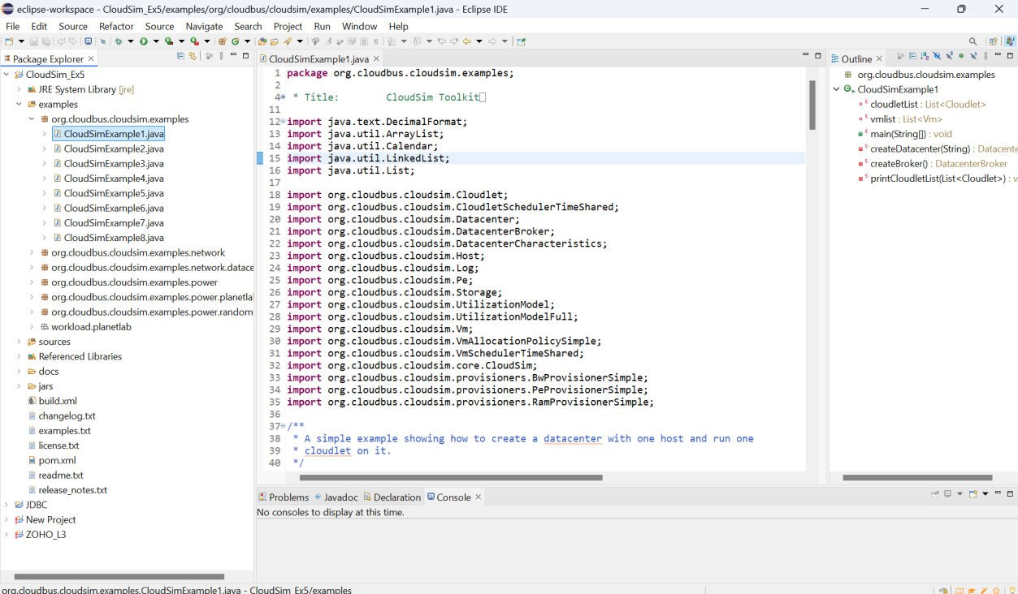

# PROGRAM:

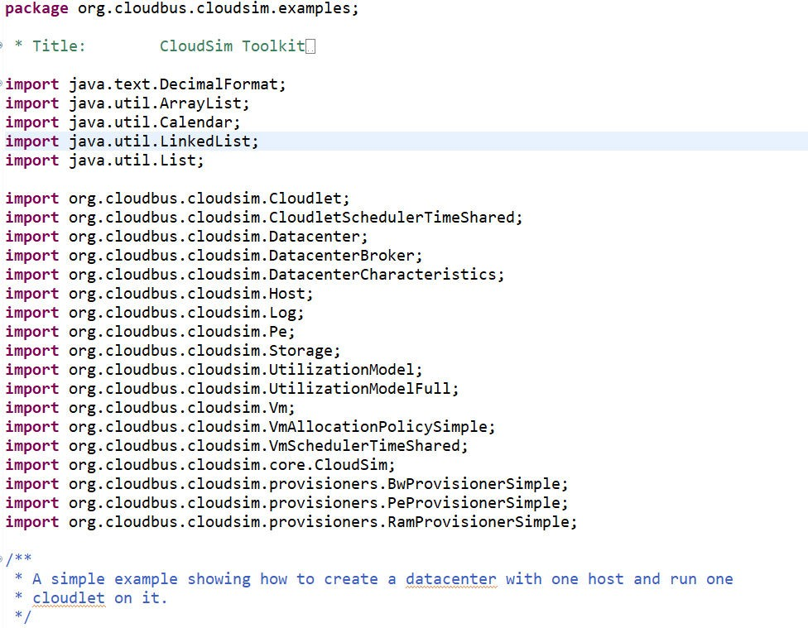

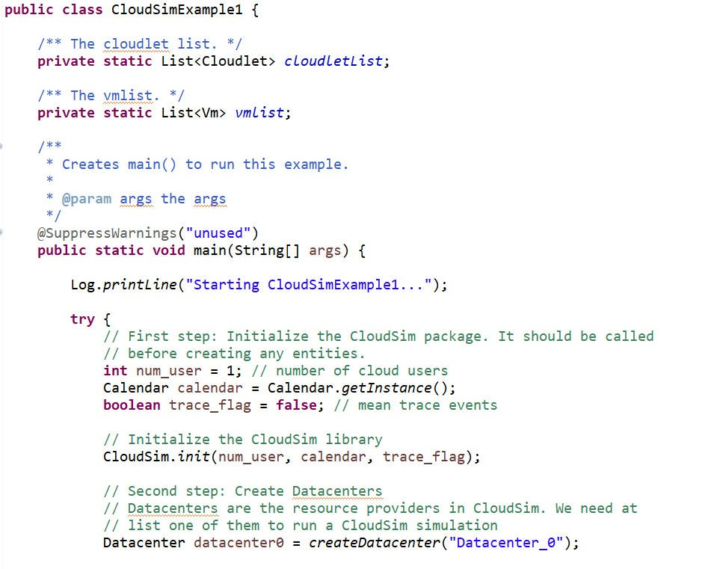

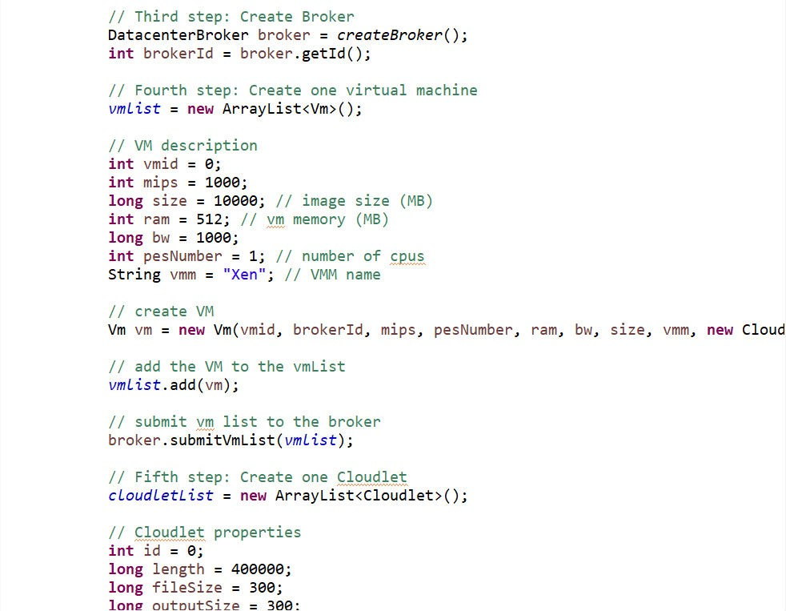

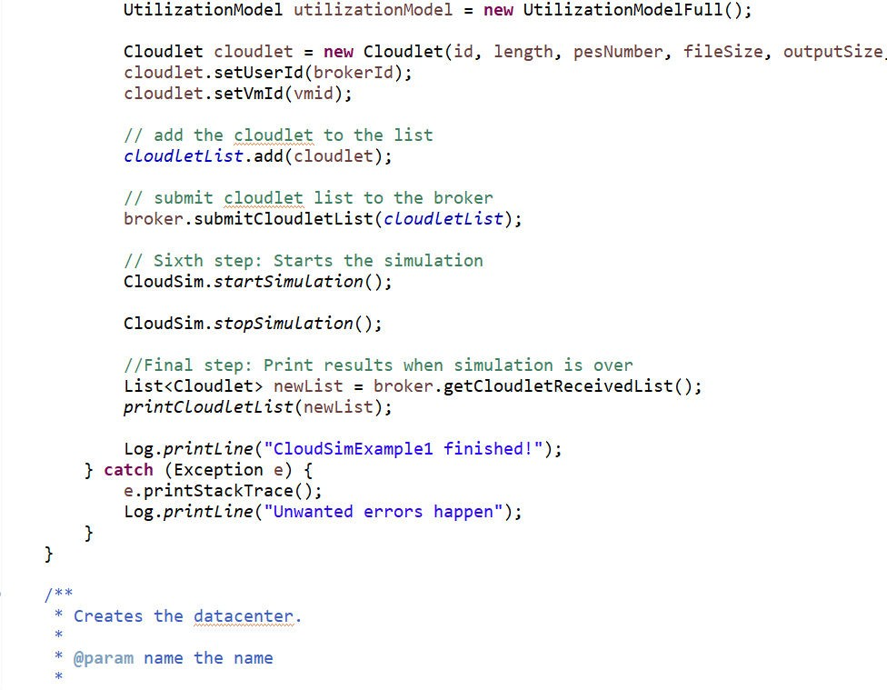

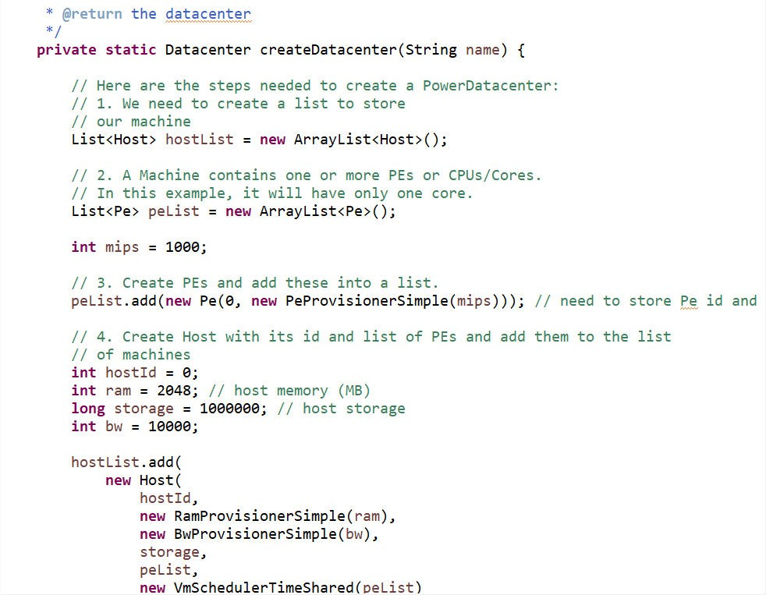

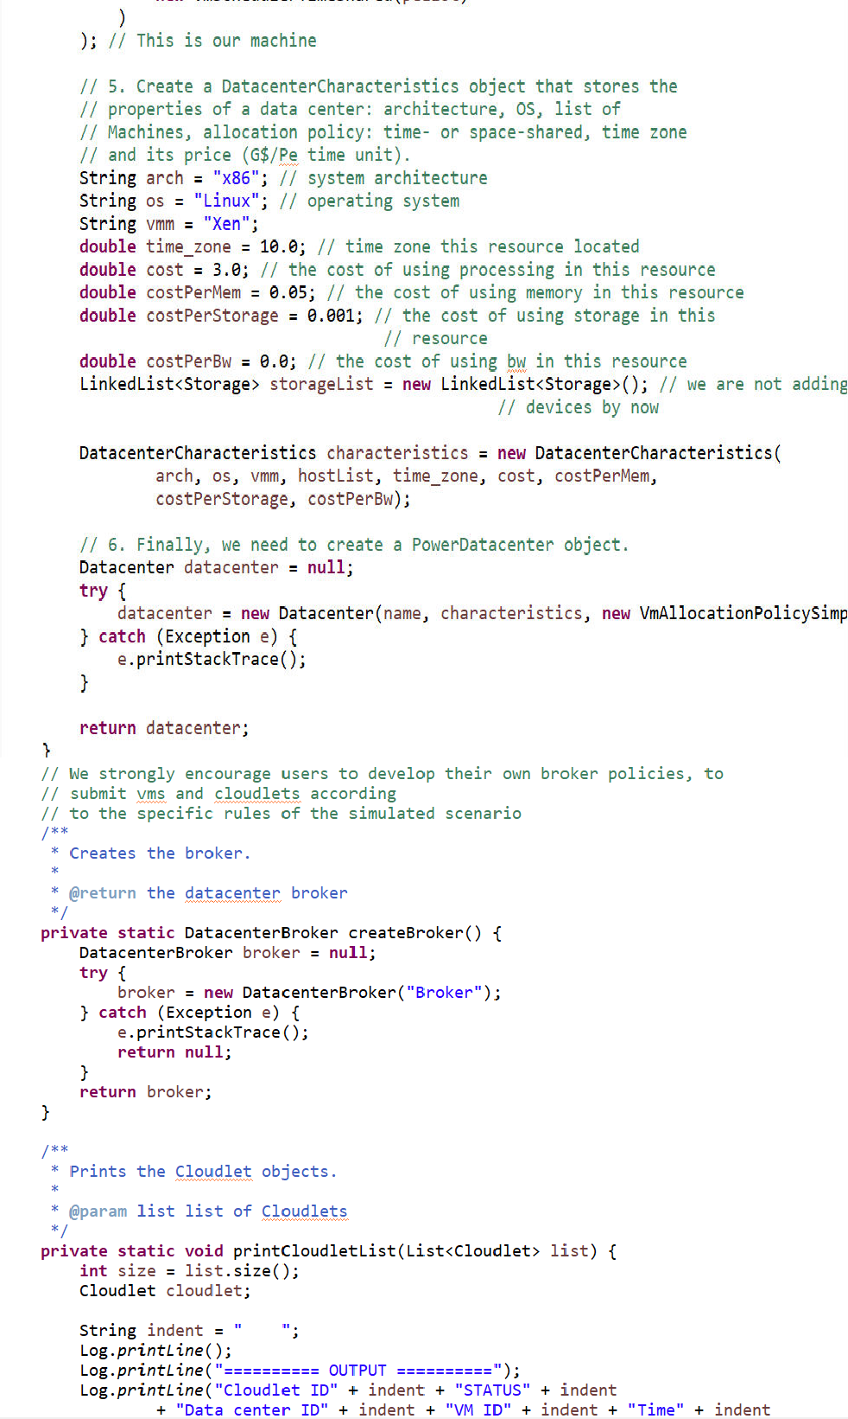

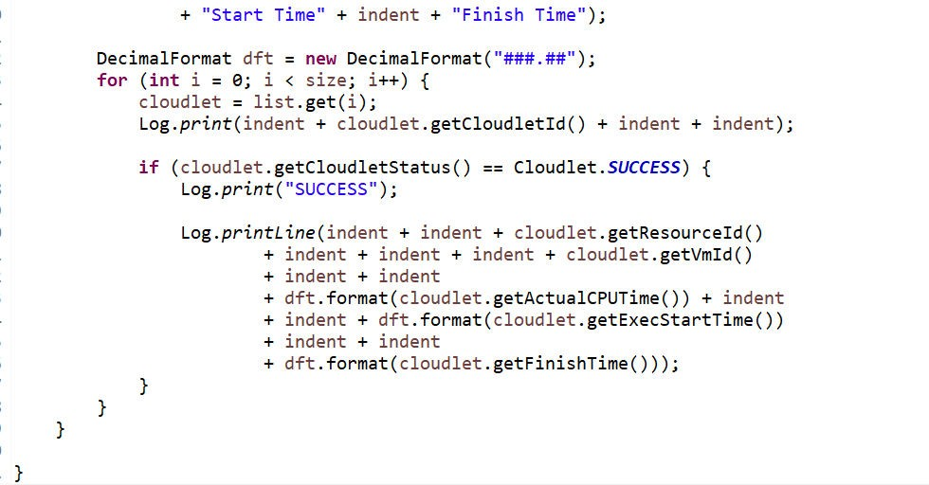

**OUTPUT:**

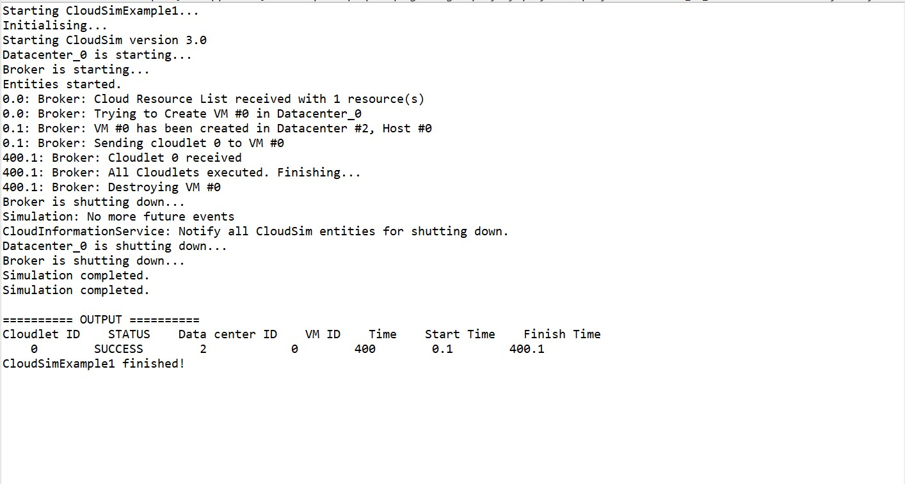

**RESULT:**

Thus, the installation and configuration of CloudSim in Eclipse IDE has been successfully completed.